Name: Luis Munoz

Course: CNT 4714 Spring 2024

Assignment title: Project 2 – Synchronized, Cooperating Threads Under Locking

Due Date: February 11, 2024

Screenshot includes simulation starting, most of the threads starting including the Internal Auditor and blocked transactions.

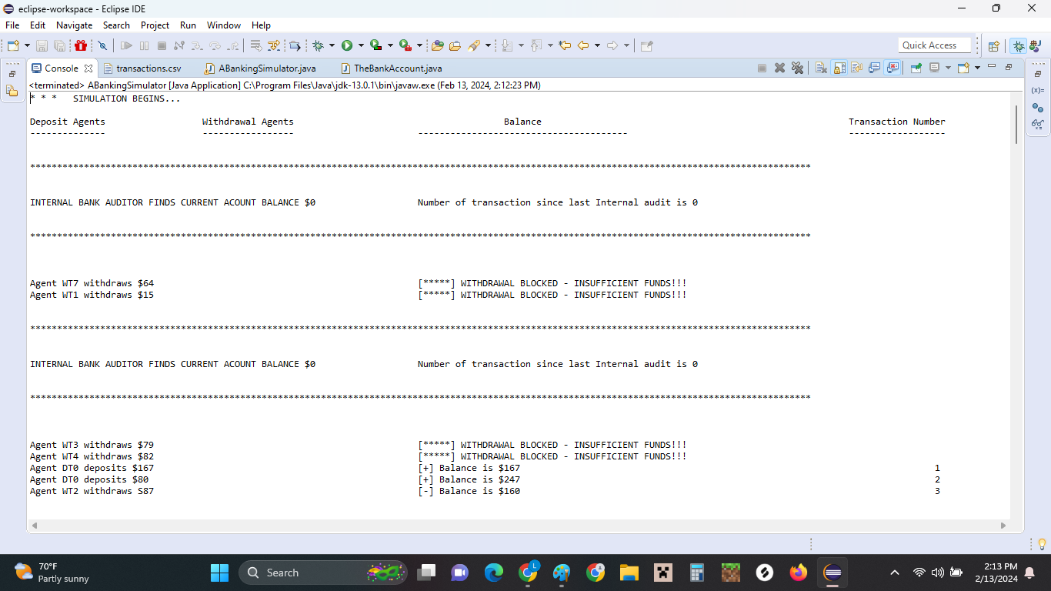

Scrolled further down to see flagged transactions

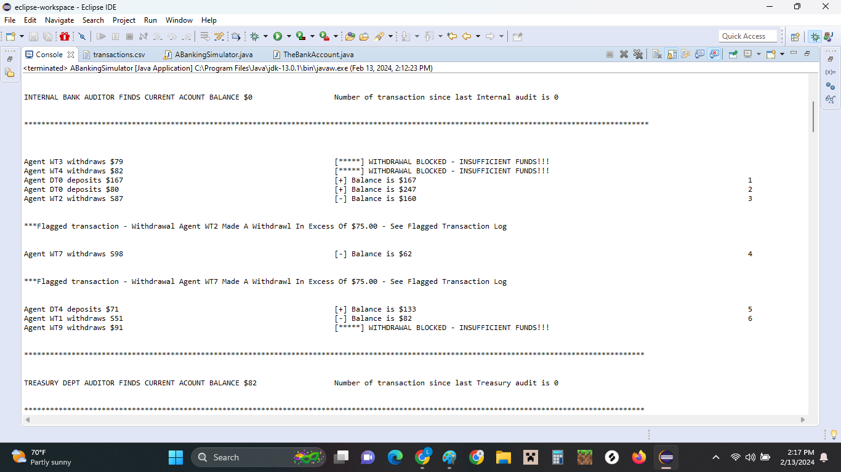

Screenshot of transactions for this run including the ones in the previous screenshot.

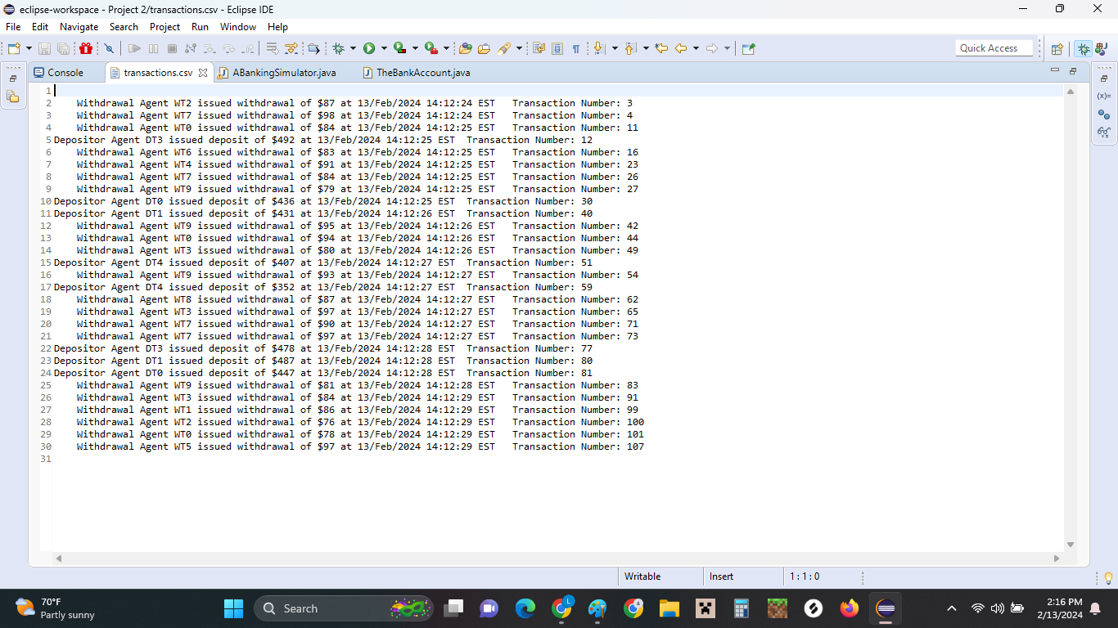

More screenshots showing other lines of the run

